# SRI-COnflat RUN summary

Jin Liu

11/1/2016

This note is the summary of three runs on SRI-conflat. The Table 1 is the LENR results. The detailed data and calculations see the attached Conflat-LENR.xlsx. The Figure 1 through Figure 3 are time series of three runs. Something happened on H2 run starting the temperature 500, highlighted in yellow and red.

Table 1. LENR, runs 10/04/2016-10/05/2016 H2

|  |  |  |  |  |  |  |  |  |  |  |  |
| --- | --- | --- | --- | --- | --- | --- | --- | --- | --- | --- | --- |
| QpulseWidth(ns) | 300 | 100 | 150 | 300 | 150 | 100 | 91.67 | 300 | 300 | 83.33 | 300 |
| Temp |  |  |  |  |  |  |  |  |  |  |  |
| 100 | -0.01 | -0.15 | -0.20 | -0.26 | -0.30 | -0.51 | -0.48 | -0.44 | -0.65 | -0.16 | -0.12 |
| 150 | -0.22 | -0.06 | -0.03 | 0.14 | 0.32 | 0.29 | 0.23 | 0.33 | 0.40 | 0.41 | 0.26 |
| 200 | 0.29 | 0.64 | 0.91 | 1.09 | 1.07 | 1.30 | 1.28 | 0.97 | 0.81 | 0.44 | 0.24 |
| 250 | 1.22 | 1.43 | 1.70 | 1.50 | 1.64 | 1.87 | 1.61 | 1.39 | 1.01 | 1.02 | 0.73 |
| 300 | 0.31 | 0.30 | 0.21 | 0.36 | 0.14 | 0.00 | -0.53 | -0.50 | -0.55 | -0.64 | -0.55 |
| 350 | 0.03 | -0.01 | 0.06 | 0.20 | 0.53 | 0.51 | 0.26 | 0.38 | 0.58 | 0.64 | 0.36 |
| 400 | -0.23 | 0.50 | 0.79 | 1.01 | 1.05 | 0.90 | 0.25 | -0.06 | 0.02 | -0.31 | -0.40 |
| 450 | 0.42 | 0.71 | 0.64 | 0.69 | 0.39 | 0.17 | -0.31 | -0.52 | -0.71 | -0.54 | -0.27 |
| 500 | -0.31 | -0.61 | -0.38 | -0.27 | 0.02 | 0.16 | 0.09 | 0.88 | 2.30 | 2.54 | 2.68 |
| 550 | 6.06 | 5.98 | 5.61 | 5.53 | 5.35 | 5.28 | 5.29 | 5.12 | 4.61 | 4.44 | 4.80 |
| 600 | 6.15 | 6.21 | 6.16 | 6.38 | 6.37 | 6.50 | 6.40 | 6.43 | 6.86 | 7.07 | 7.09 |

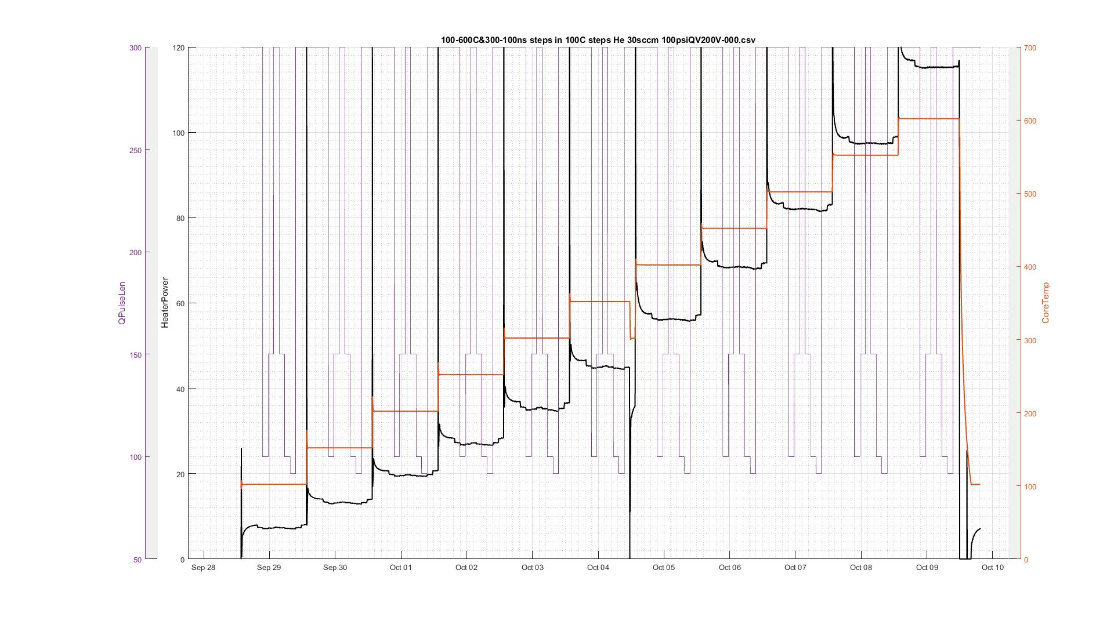

Figure 1. He runs

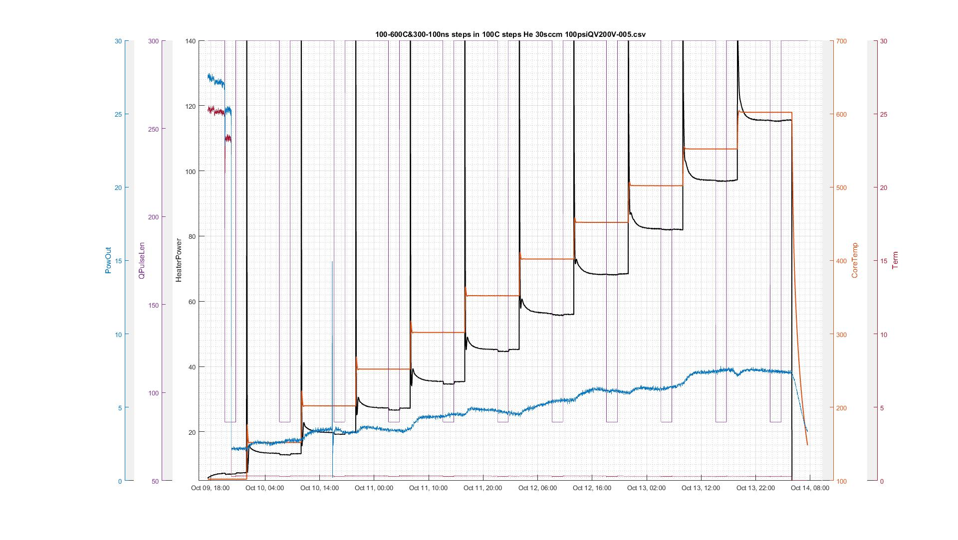

Figure 2. Run2 He

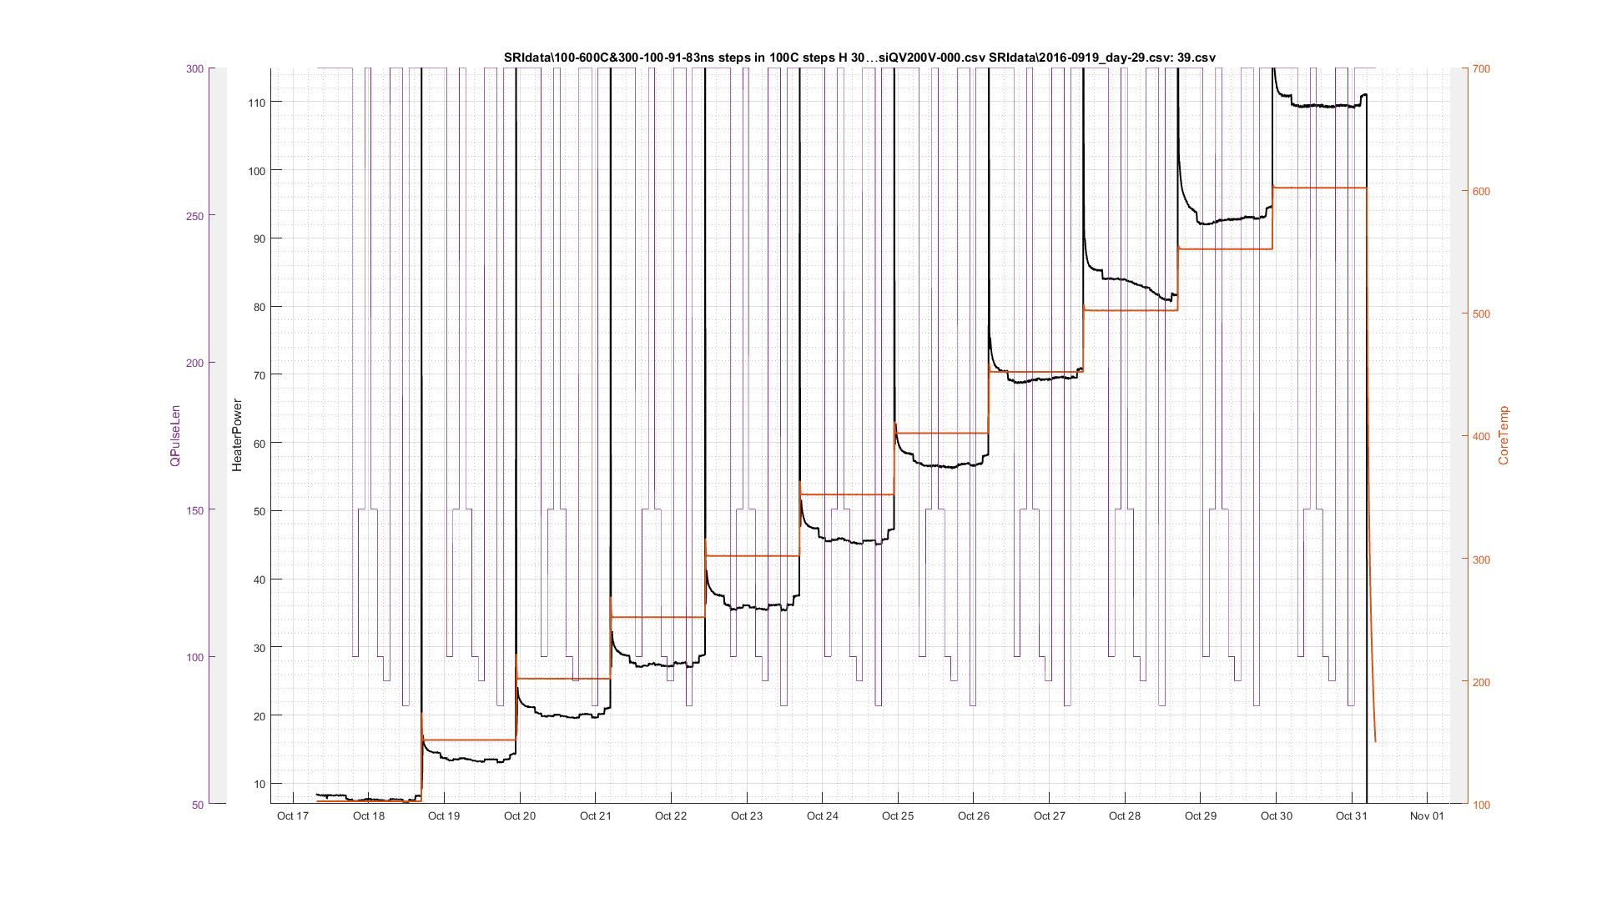

Figure 3. Run3 H2